Web application Design

Layout

The layout of my web application will mainly consist of a dashboard view and edit pages. The pages will not be long so minimal scrolling will be needed. The layout that has been developed was made with the Bootstrap framework in mind, using a 12 x 12 column grid. At present, the website will be desktop only, meaning responsiveness for mobile will not be included. This decision was made due to the many small parts on the dashboard which would require an almost completely reworked design to be fit for mobile use. The project scope is not wide enough for this feature.

I began the design process by sketching out different layouts of each page. I went through several iterations of the dashboard and profile page (figure 12) on paper before moving to a digital wireframe. I imported images of the paper prototypes to Miro and cut up the sections to rearrange them on the board in additional iterations (figure 13). 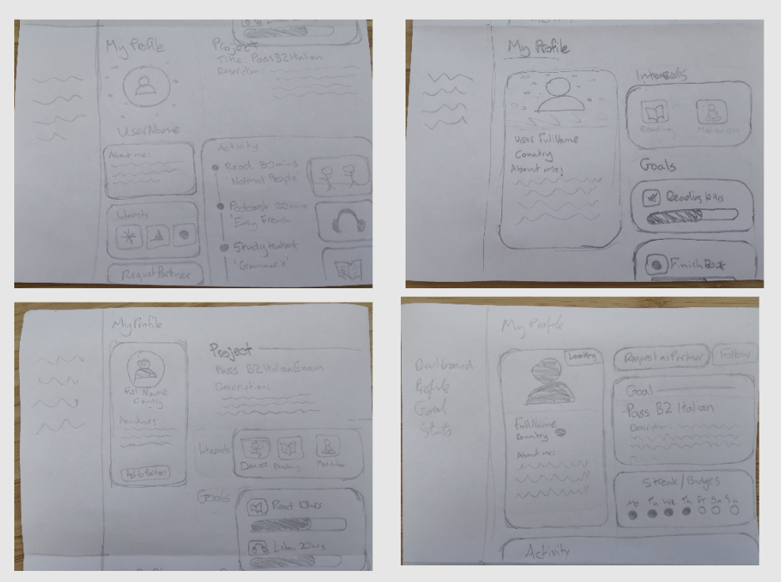
Figure 12 - Profile Paper Prototype
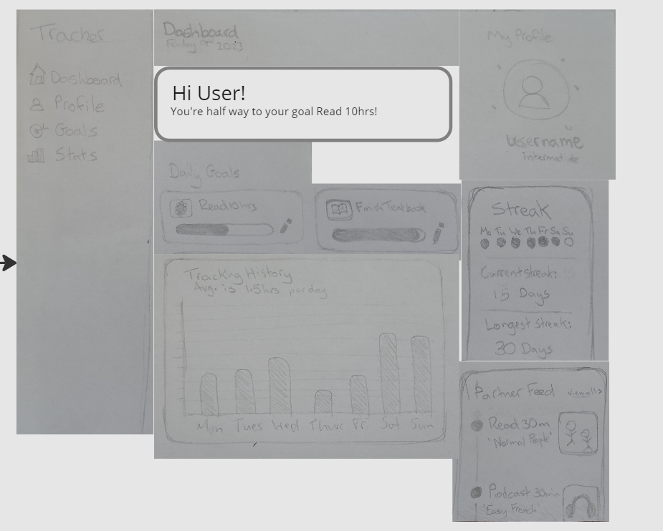
Figure 13 - Paper prototype in Miro

The dashboard view will be made up of modular sections, each containing its own information regarding elements of the web application (figure 14).
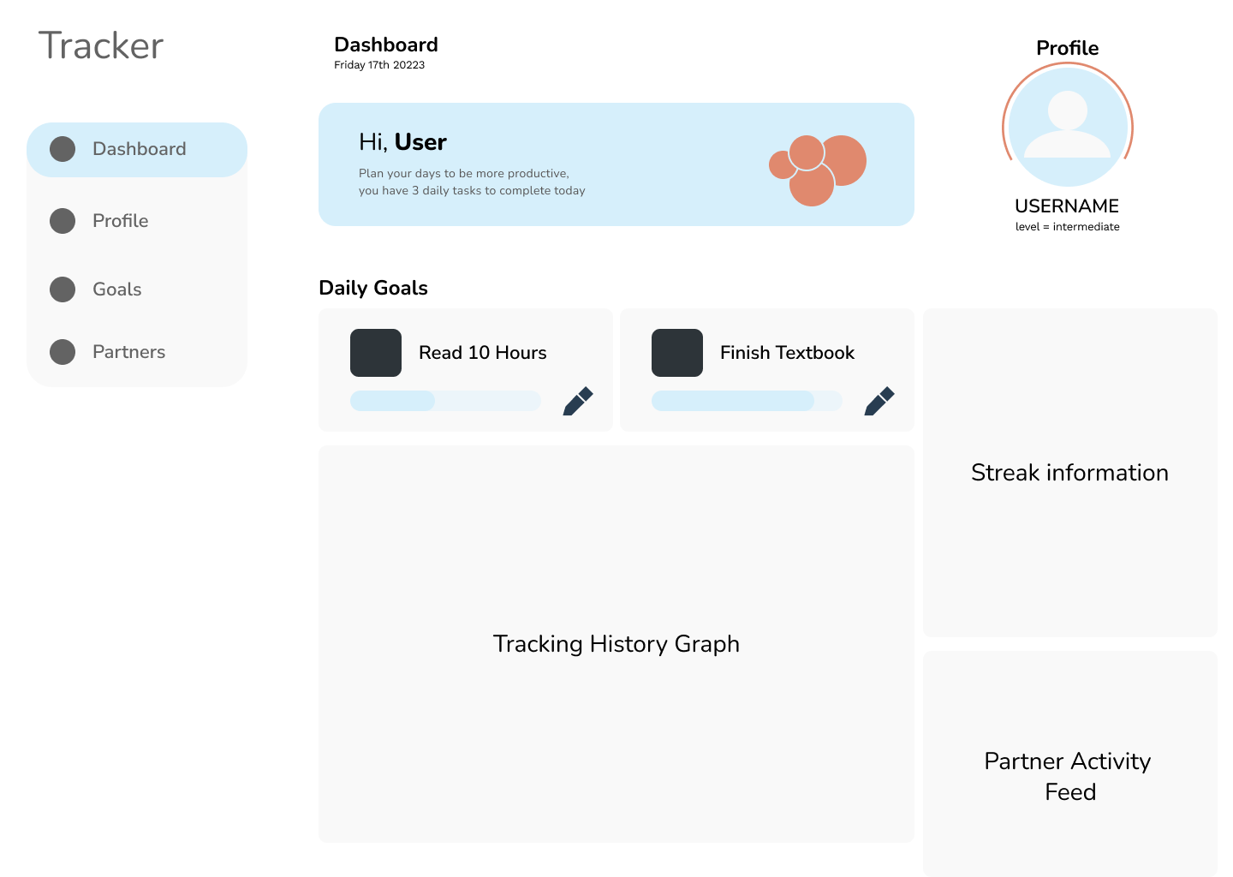
Figure 14- Dashboard

This page gives an overview of the users’ daily goals, a tracking history graph (this may be reworked as an activity feed if including a graph proves to be outside of the projects scope), streak info and the activity feed from the users partner. A welcome message will greet the user also.

The users profile page (figure 15) is publicly viewable and will contain all relevant information. A short ‘about me’ section and interests are to give the user space to display their personality. A button to request to become partners with the user is found underneath this section. The most important sections are the Project information and tracking activity. The user will have space to fully explain what their project is and show their recent activity.

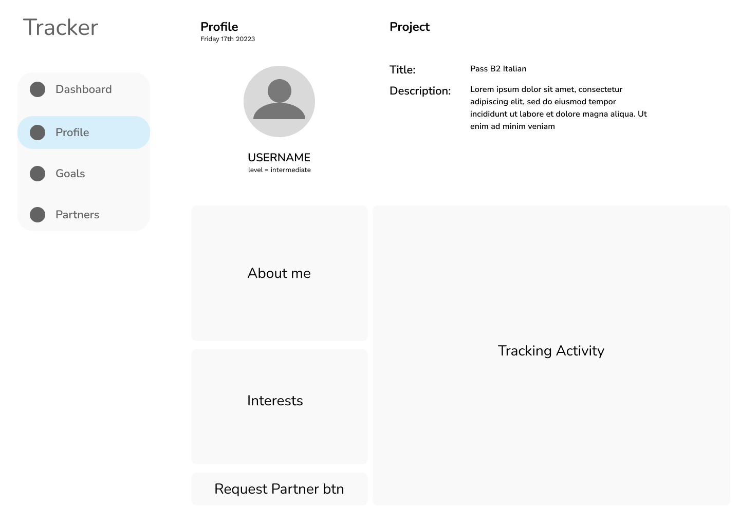
Figure 15 – Profile
The Partners page (figure 16) is the index for users to find a partner or people to follow. It will display each users profile picture, username, a short description, their country flag in the top right corner and underneath that, a tag to show if they are currently looking for a partner. Clicking on any of these will bring you to their full profile.

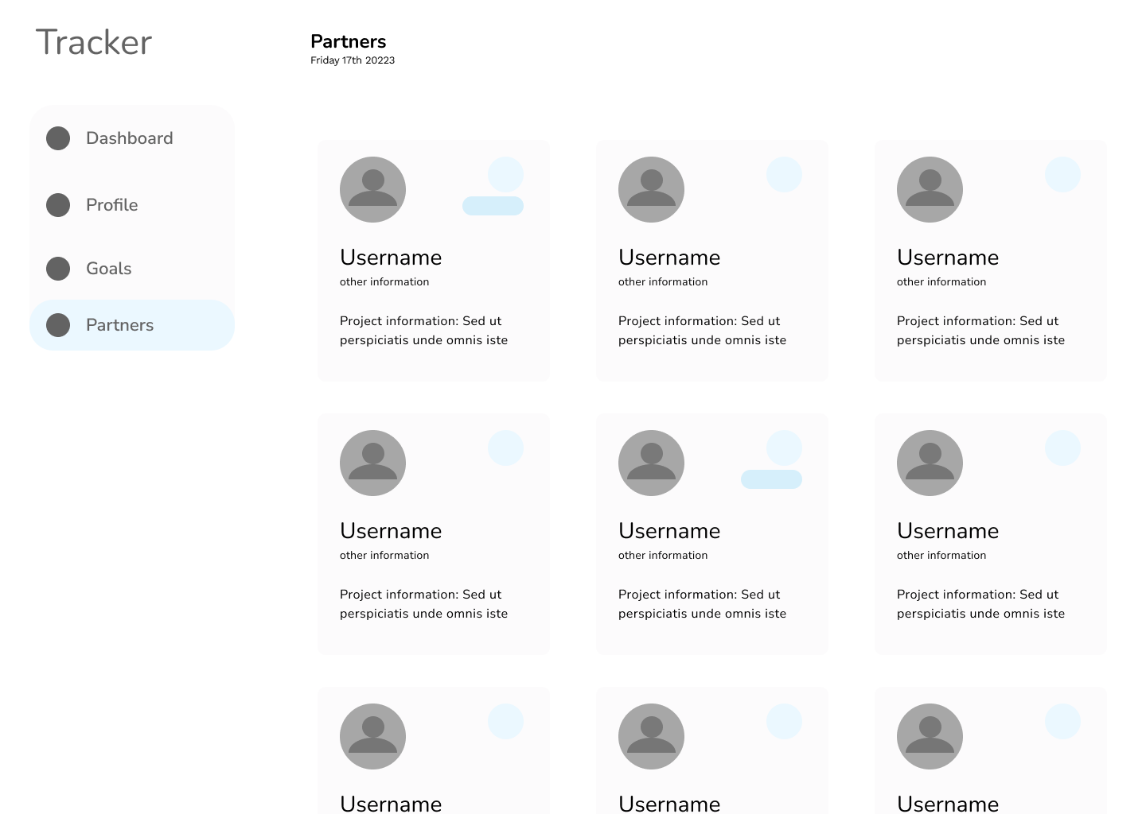
Figure 16 - Partners

Users will need to create and edit their profiles, so a simple form page is needed. The user can change their profile image and edit any other information. The Interests section will be a dropdown menu of predefined options, allowing for a max of three to be selected.
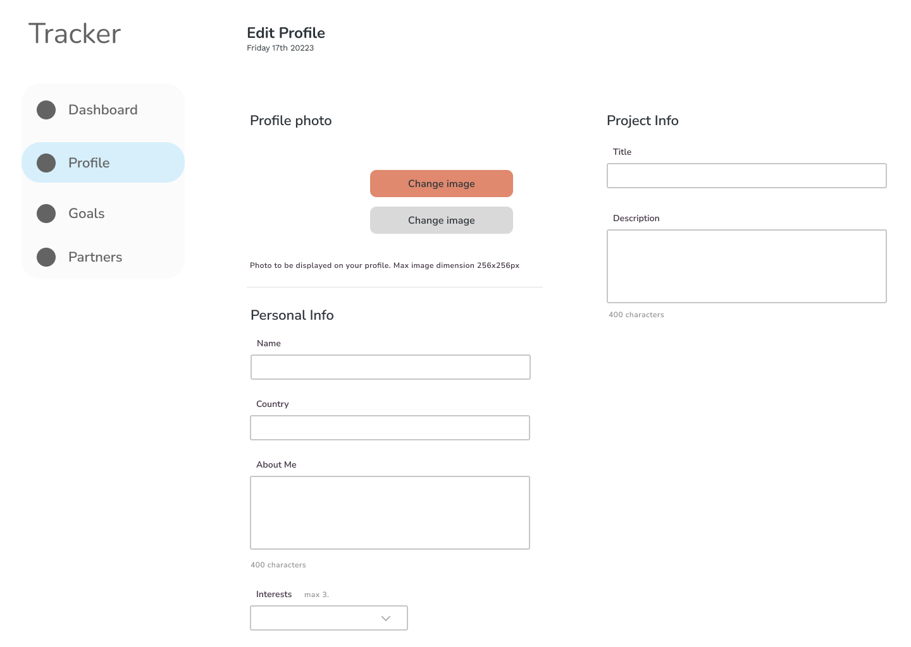
Figure 17 - Edit Profile

Interaction

The navigation elements are all located on the left of the screen in a vertical nav bar (figure 17). The Daily Goals progress bars include an edit button which opens a field for the users to input data (figure 16). The users can edit their profile through an edit form and replace the profile image (figure 20).

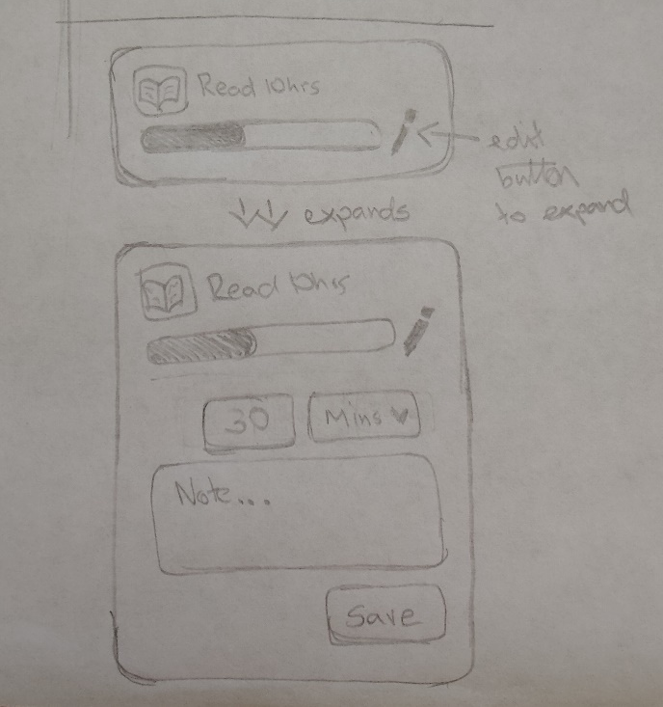
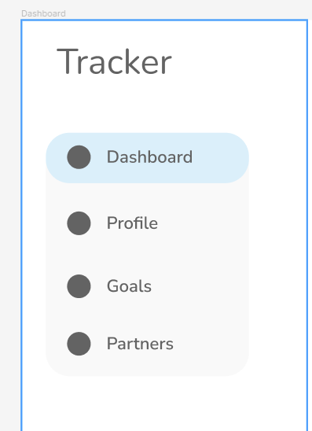
Figure 18 - Daily Goals edit
Figure 19 - Navigation Bar
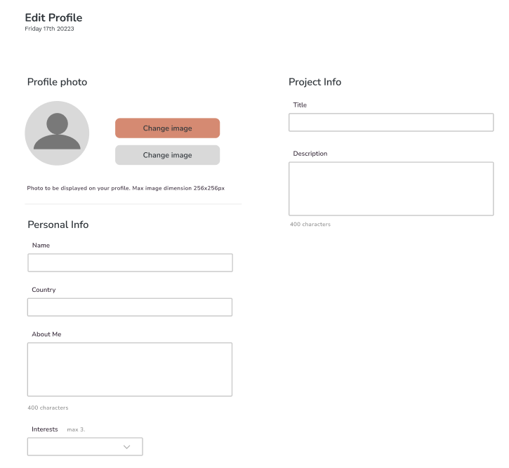
Figure 20 - Profile Edit Form

Colour schemes

The colour palette (figure 21) I choose consists of light, low saturated tones and an orange accent colour. The background colour will be pure white, an off-white will be used to separate elements from the background, such as with the navbar (figure 19). The accent orange will be used sparingly and to bring quick attention to important elements of the page or to give the page a more balanced visual look, as done on the dashboard (figure 22).

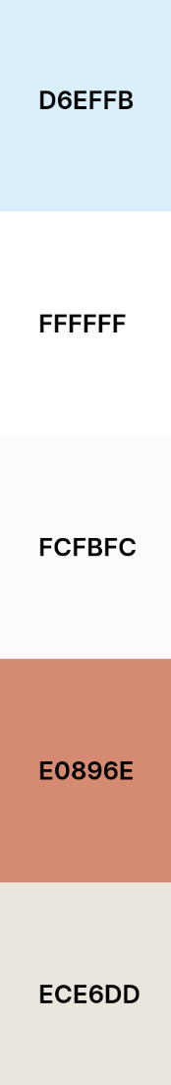
Figure 21 - Colour Palette

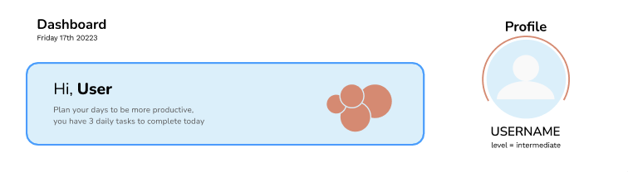
Figure 22 - Accent Colour on Dashboard

Font choices

To find an appropriate font I used a community template from Figma called Google Fonts: Pairings. This template had examples of many fonts and a suitable font pairing, usually a serif and sans-serif font that work well together. The fonts chosen for this project were Nunito and Nunito Sans. These were chosen because they are a light font with a slightly soft feel. Nunito suits the website because it has soft edges and a slightly rounded look, this goes well visually with the rounded edges of the elements used throughout the website. The result is a soft and welcoming experience for the user.

Figures 23 and 24 show the main title, label and body font sizes and weights used throughout most of the website. The community resource used to find the fonts included examples of the variety of font sizes and weights recommended. These were then all saved in the main Figma project in a local styles collection for easy access.

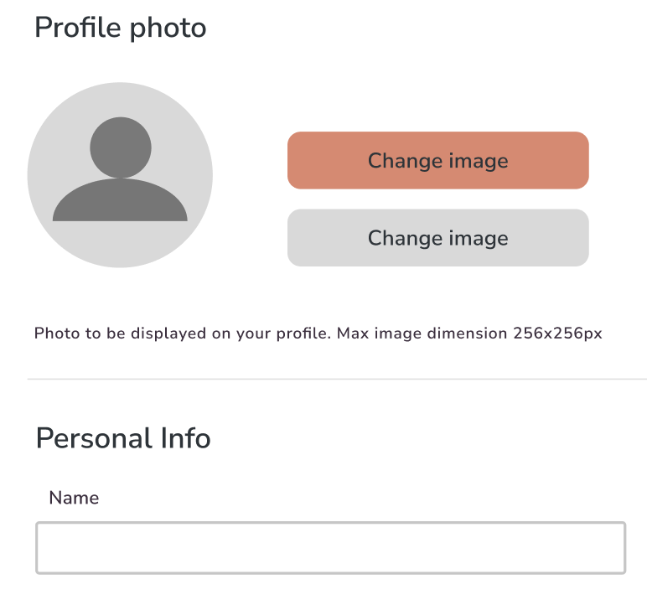
Figure 23 - Title and body fonts

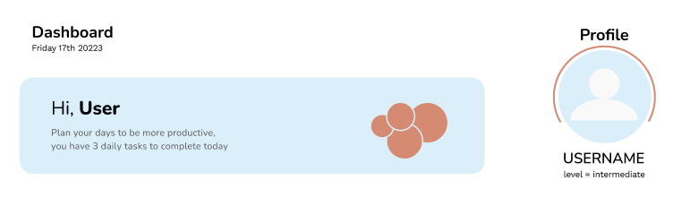
Figure 24- Fonts on dashboard

Wireframes

From the home screen/dashboard the user can click on ‘Profile’ in the navbar and they are brough to the profile page. If they have visited their own profile, an edit icon will appear beside the page title which will bring them to the Profile Edit form page. The user can access the Partners index page by clicking on ‘Partners’ in the navbar. Clicking on any of the users on the page will bring up that users’ profile.

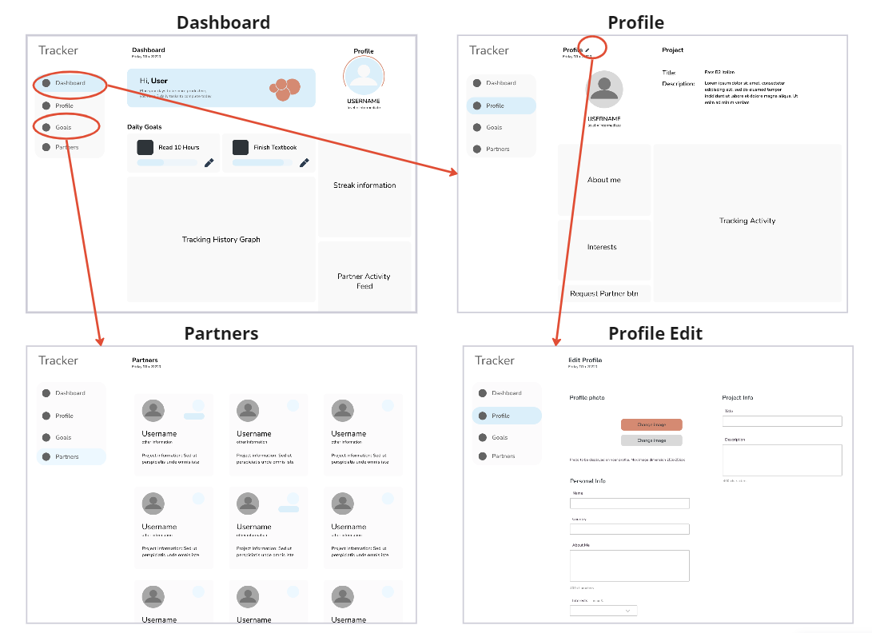
Figure 25 - Navigation Diagram

